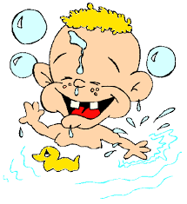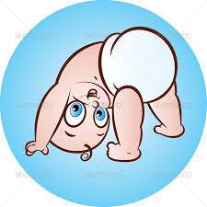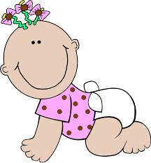

JOHNS CREEK HIGH SCHOOL SENIOR BABY PHOTO CONTEST

We are excited to announce the annual JCHS senior baby photo contest! This event is a hit with the seniors and it serves as a great fundraiser for the Senior Celebration. Contest winners will be published in the yearbook along with their name and category.

For $5 per photo, enter your student’s photo in a category of your choosing. You receive one free entry with your paid Senior Activity Fee. You may enter as many photos as you like. The deadline for submissions is Friday, January 19th. All photos will be on display at JCHS for one week. Seniors will vote for their favorites on Wednesday, January 31st. Contest winners will be announced in the yearbook.

In order to be eligible, photos must be of a JCHS senior student from birth to age 3. No inappropriate photos will be accepted.

PHOTOS WILL NOT BE RETURNED!!!

Photo Categories
Mr. Cutest JCHS Miss Cutest JCHS
Most Athletic Best Dressed
Best Eyes Most Photogenic
Funniest Baby Most Mischievous
Messiest Baby Best Personality
Most Intellectual Best Hair

JCHS BABY CONTEST ENTRY FORMS
Be a part of a JCHS senior tradition while helping to support the Senior Celebration! Fill out one form per photo and attach to the appropriate photo. Make checks payable to JCHS PTSA, Attn. Senior Baby Photo Contest.

Remember that you receive one free photo entry if you have already paid a Senior Activity Fee*. Be sure to check the appropriate line on the entry form to indicate if it is your free photo or a paid entry. Photos, forms and checks can be submitted to the front office.

Questions? Email cassidy.annmarie@gmail.com

*If you haven’t signed up for Senior Activities and you would like to, go to jchsptsa.com and click on “seniors.”

Student’s Name________________________________________________________

Phone #____________________________ Category__________________________

This is my free photo ________ Paid entry ($5)________

Checks payable to JCHS PTSA - write “Senior Baby Photo Contest” on the memo line

Student’s Name________________________________________________________

Phone #____________________________ Category__________________________

Checks payable to JCHS PTSA - write “Senior Baby Photo Contest” on the memo line

Student’s Name________________________________________________________

Phone #____________________________ Category__________________________

Checks payable to JCHS PTSA – write “Senior Baby Photo Contest” on the memo line

