Red Ribbon Week Resources for Families:
Parents Take the Red Ribbon pledge and encourage your students to too by visiting http://redribbon.org/pledge/
Children of parents who talk to their teens regularly about drugs are 42% less likely to use drugs than those who don't, yet only a quarter of teens report having these conversations.

Think Red Ribbon Week isn’t relevant to your student Watch this:
In the affluent Atlanta suburbs, there's a deadly secret http://stoprxabuseinga.org/the-triangle-investigation/

http://www.drugfree.org/
Parent toolkit for preventing drug use at every age and other useful resources http://www.drugfree.org/the-parent-toolkit/

Study: Teen exposure to drugs, alcohol affects chance of use in adulthood
https://noys.org/focusareas/easy-access/

How Porn Affects The Brain Like A Drug
http://fightthenewdrug.org/
http://fightthenewdrug.org/family-media-standard/

Resources from Drug Enforcement Agency (DEA)
Movie Opioid Addiction
Chasing the Dragon: The Life of an Opiate Addict
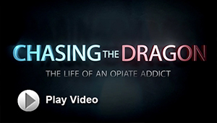
An opioid and prescription drug abuse epidemic is sweeping the country, impacting all segments of society. To help raise awareness of this epidemic and to help educate young people on the dangers of addiction, the FBI and DEA have released the documentary Chasing the Dragon: The Life of an Opiate Addict, a compilation of heart-wrenching first-person accounts by addicts and family members of addicts about their experiences.
https://www.dea.gov/media/chasing-dragon.shtml
https://www.dea.gov/index.shtml

Get Smart About Drugs

A DEA resource for parents, educators & caregivers
https://www.getsmartaboutdrugs.com/

Resources from Center for Disease Control and Prevention (CDC)
Underage Drinking:
http://www.cdc.gov/alcohol/fact-sheets/underage-drinking.htm
http://www.cdc.gov/alcohol/fact-sheets/minimum-legal-drinking-age.htm

The Youth Risk Behavior Surveillance System (YRBSS) monitors six types of health-risk behaviors that contribute to the leading causes of death and disability among youth and adults, including—
- Behaviors that contribute to unintentional injuries and violence
- Sexual behaviors related to unintended pregnancy and sexually transmitted diseases, including HIV infection
- Alcohol and other drug use
- Tobacco use
This link will allow you to see the responses of GA high school students from 2015
https://nccd.cdc.gov/youthonline/App/Results.aspx?TT=A&OUT=0&SID=HS&QID=QQ&LID=XX&YID=2015&LID2=&YID2=&COL=S&ROW1=N&ROW2=N&HT=QQ&LCT=LL&FS=S1&FR=R1&FG=G1&FSL=S1&FRL=R1&FGL=G1&PV=&TST=False&C1=&C2=&QP=G&DP=1&VA=CI&CS=Y&SYID=&EYID=&SC=DEFAULT&SO=ASC
http://www.cdc.gov/healthyyouth/data/yrbs/pdf/trends/us_drug_trend_yrbs.pdf (note data only up to 2013)
http://www.cdc.gov/healthyyouth/data/yrbs/pdf/2015/ss6506_updated.pdf

Heroin use more than doubled among young adults ages 18–25 in the past decade
http://www.cdc.gov/vitalsigns/heroin/index.html

Resources from the National Institute on Drug Abuse, a division of The National Institute of Health
https://www.drugabuse.gov/

Family Checkup: Positive Parenting Prevents Drug Abuse
https://www.drugabuse.gov/family-checkup
Preventing Drug Use among Children and Adolescents (In Brief)
https://www.drugabuse.gov/publications/preventing-drug-abuse-among-children-adolescents/acknowledgments

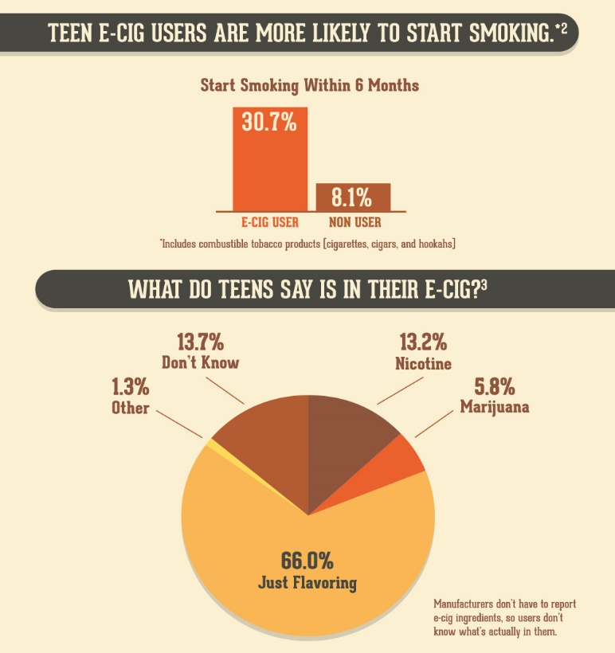
https://www.healthychildren.org/English/ages-stages/teen/substance-abuse/Pages/E-cigarettes.aspx

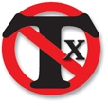http://safetextingcampaign.com/IWillNotTextWhileDriving.aspx?cms=6964

