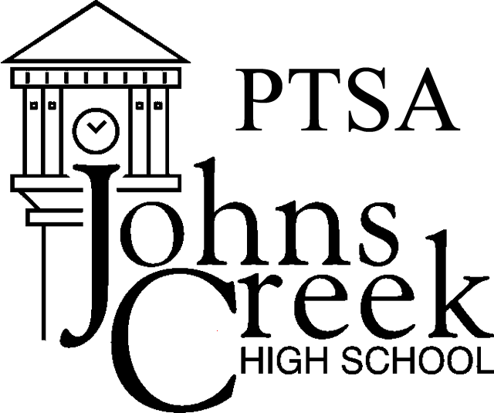
JOHNS CREEK HIGH SCHOOL PTSA
2016-2017 TEACHER/STAFF MEMBERSHIP FORM

Benefits to teacher members – Join for only $10 and get:

- $ 50 reimbursement for classroom supplies. These teacher stipends are for supplies used in your classroom. Use the Stipend form to request your check. Join by September 30 to be eligible.

- Birthday Message and Treat from PTSA!

- Apply for Mini-grants – Over 30 mini-grants were awarded last year -
  - $ 14,000 in books, technology, furniture, lab supplies etc! Join by
  - September 30 to be eligible.

- Priceless Benefits - Welcome Back Breakfast, Curriculum Night Dinner, Teacher Appreciation Week, Catered Lunches and lots of extras throughout the school year.

.Pay online at JCHSPTSA.com or Return Membership Form to front office.

.Member Information (please print clearly) .

Staff Member’s Name
Today’s Date

Your email:
Department

Members will receive our Weekly E-blasts and Monthly Newsletter.

Top of Form

Teacher/Staff – 1 membership $ 10.00
Donation to Laurel Schmitt
Service Scholarship (100% tax deductible) $______

TOTAL ENCLOSED $______

Thank you for supporting JCHS PTSA. It Takes All of Us! Volunteer - Visit JCHSPTSA.com for more information. Look for our PTSA E-blast and newsletter for important school news! All members will be added to our mailing list.
If you have any questions, contact VPs of Membership Marcia Grimsley jmgrimsley@comcast.net or Kathy Read klread@hotmail.com

For PTSA use only:

Amount Received

Check #

and/or Cash Amount

Date
Received By

