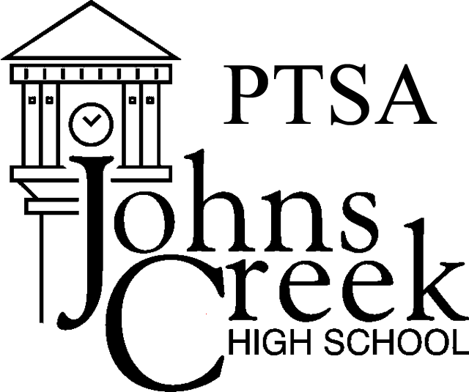
JOHNS CREEK HIGH SCHOOL PTSA
2018-2019 TEACHER/STAFF MEMBERSHIP FORM

Benefits – Join for only $10 and receive:

- $50 reimbursement for classroom supplies. These teacher stipends are for supplies used in your classroom. Use the Stipend form to request your check. Join by September 30 to be eligible.

- Birthday Message and Treat from PTSA!

- Apply for Mini-grants – Over 30 mini-grants were awarded last year over $14,000 in books, technology, furniture, lab supplies etc!
  - Join by September 30 to be eligible.

- Priceless Benefits - Welcome Back Breakfast, Curriculum Night Dinner, Teacher Appreciation Week, Catered Lunches and lots of extras throughout the school year.

- Member of National and State PTA organizations.

PAY online at www.jchsptsa.com/join-ptsa/ or Return membership Form to the Front Office.

Teacher Member Information (please print clearly)

Staff Member Name
Today’s Date _____________

Your email
Department _________________

Members will receive our Weekly E-blasts and Monthly Newsletter.

Top of Form

Teacher/Staff – 1 membership $ 10.00
Donation to Laurel Schmitt
Service Scholarship (100% tax deductible) $______

TOTAL ENCLOSED $______

Thank you for supporting JCHS PTSA. It Takes All of Us! Volunteer - Visit www.JCHSPTSA.com for more information. Look for our PTSA E-blast and newsletter for important school news! All members will be added to our mailing list. If you have any questions, contact VP of Membership Sandy Garrett at membership@jchsptsa.com.

For PTSA use only:

Amount Received

Check #

and/or Cash Amount

Date
Received By

